BEROUKHIM KEYVAN

mh -n 0.65 IRM.inr.gz | xvis -nu mh -n 0.8 IRM.inr.gz | xvis

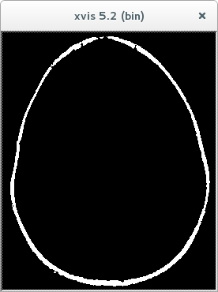
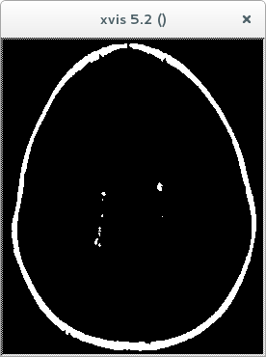
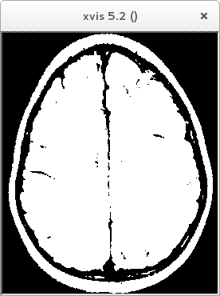
mh -n 0.2 IRM.inr.gz | xvis -nu

